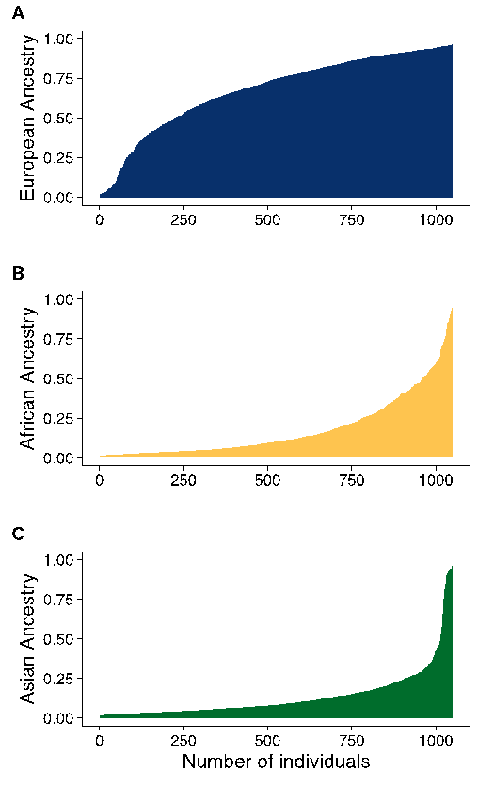
Figure S2. Graphic representation of the individual interethnic admixture estimate in an admixed population from São Paulo, using R software, for k= 3. X-axis represents the number of individuals and Y-axis represents the proportion of correspondent ancestry: European (blue), African (yellow) and Asian (green).

