Table S2. Location and photodocumentation of the 73 promoter trap events identified to insertion site.
Jump | Inserted gene | Insertion location | Chromosome location | GenBank accession | Phenotype | Image
AsGTv3-001 | ASTE015199 | KB664888:788098-788101 | 3L 40 C(2) | KS331897 | muscle, stunted
AsGTv3-002 | ASTE002920 | KB664488:1528700-1528703 | 2R 15 A(3) | KS331898 | mouthparts
AsGTv3-004 | ASTE003097 | KB664418:103847-103850 | 3L 45 C(1) | KS331900 | fat body, neural, imaginal disc | 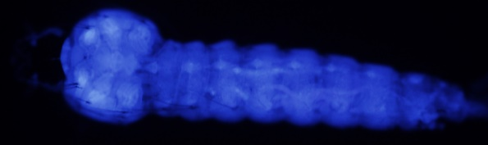
AsGTv3-005 | ASTE009452 | KB664457:422497-422500 | n/a | KS331901 | fat body, muscle, neural | 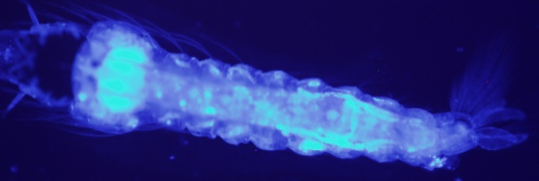
AsGTv3-006 | ASTE003052 | KB664429:516665-516668 | n/a | KS331902 | neural, fat body, imaginal disc | 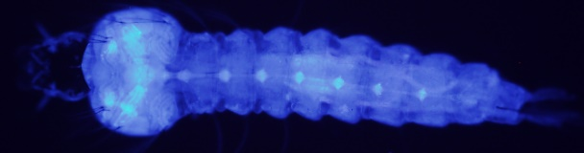
AsGTv3-007 | ASTE007011 | KB664459:342713-342716 | n/a | KS331903 | fat body, imaginal disc, neural | 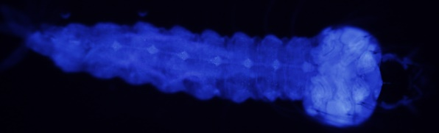
AsGTv3-008 | ASTE010716 | KB664458:389285-389288 | 2R 19 A(2) | KS331904 | fat body | 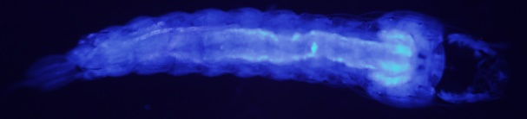
AsGTv3-010 | ASTE008390 | KB664427:246010-246013 | 2R 19 A(2) | KS331906 | neural, fat body | 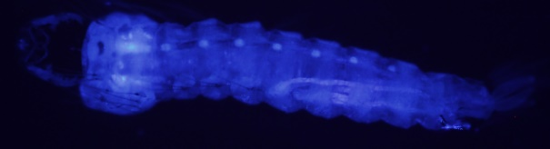
AsGTv3-011 | ASTE003097 | KB664418:103847-103850 | 2L 28 C(2) | KS331907 | fat body | 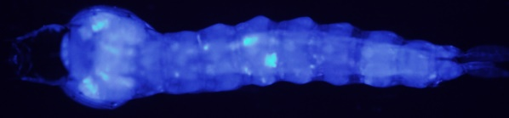
AsGTv3-012 | ASTE006277 | KB664587:104309-104312 | 3L 46 D | KS331908 | muscles, fat body | 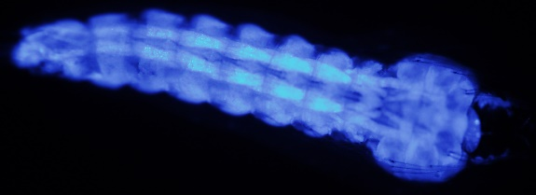
AsGTv3-013 | ASTE009452 | KB664457:422697-422700 | 2R 12 B(3) | KS331909 | fat body, muscle, neural
AsGTv3-014 | ASTE006277 | KB664587:104580-104583 | 2R 12 B(3) | KS331910 | neural, fat body, Malpighian tubules
AsGTv3-016 | ASTE007384 | KB664499:1131957-1131960 | n/a | KS331912 | fat body, muscles | 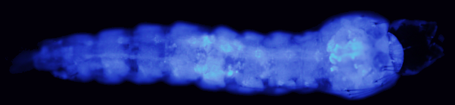
AsGTv3-018 | ASTE014371 | KB664412:530754-530757 | n/a | KS331914 | neural, imaginal disc, cuticle
AsGTv3-019 | ASTE009563 | KB664400:667259-667262 | 3R 31 C(2) | KS331915 | neural, imaginal disc
AsGTv3-020 | ASTE007572 | KB664483:363558-363561 | 3R 35 A(2) | KS331916 | neural, fat body, Malpighian tubules, gastric cecae
AsGTv3-021 | ASTE007011 | KB664459:342713-342716 | 3R 35 A(2) | KS331917 | fat body, imaginal disc, neural | 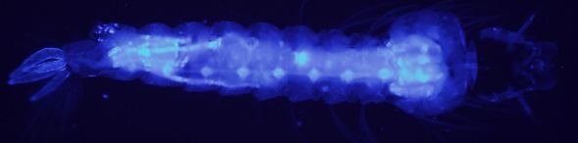
AsGTv3-023 | ASTE003400 | KB664465:129328-129331 | 3R 35 A(2) | KS331919 | cuticle | 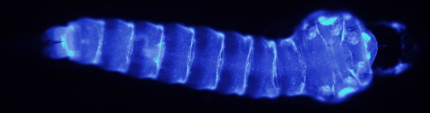
AsGTv3-024 | ASTE003097 | KB664418:103847-103850 | 3R 35 A(2) | KS331920 | fat body | 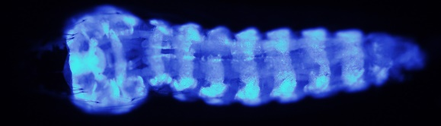
AsGTv3-025 | ASTE011383 | KB664644:852319-852322 | n/a | KS331921 | fat body, neural, imaginal disc | 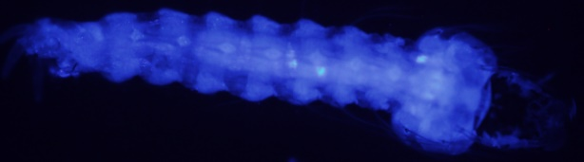
AsGTv3-026 | ASTE001365 | KB664622:83068-83071 | 2R 9 C(2) | KS331922 | fat body
AsGTv3-027 | ASTE006314 | KB664288:636693-636696 | 3L 44 A | KS331923 | imaginal disc, muscle, fat body | 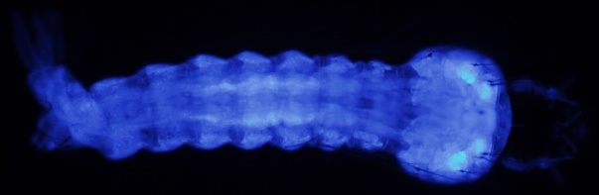
AsGTv3-028 | ASTE007384 | KB664499:1131957-1131960 | n/a | KS331924 | muscle | 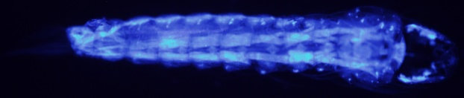
AsGTv3-029 | ASTE008016 | KB664755:636235-636238 | 2L 21 B(4) | KS331925 | neurohumeral organs, fat body, neural | 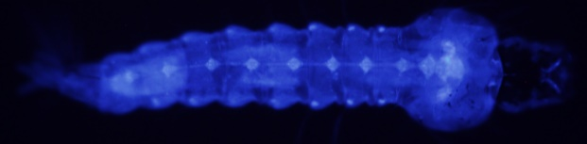
AsGTv3-030 | ASTE003097 | KB664418:103847-103850 | 3L 46 D | KS331926 | salivary glands, fat body | 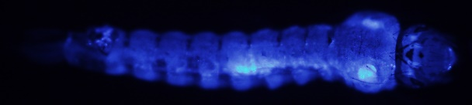
AsGTv3-032 | ASTE004847 | KB664610:355489-355492 | 3L 46 D | KS331928 | cuticle
AsGTv3-034 | ASTE002919 | KB664488:1485824-1485827 | 3L 38 F(1) | KS331930 | neurohumeral organs
AsGTv3-035 | ASTE001329 | KB665188:541090-541093 | n/a | KS331931 | neural, neurohumeral organs, fat body
AsGTv3-037 | ASTE008789 | KB664517:306066-306069 | 3R 33 B(1) | KS331933 | imaginal disc, fat body, neural | 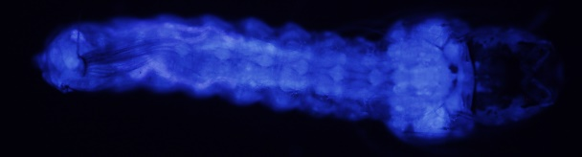
AsGTv3-039 | ASTE006384 | KB664288:1560514-1560517 | 3R 33 B(1) | KS331935 | fat body | 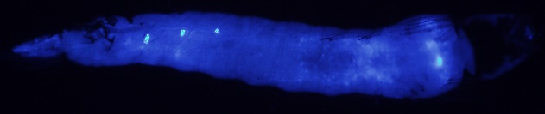
AsGTv3-040 | ASTE008287 | KB664477:412355-412358 | 3R 33 B(1) | KS331936 | imaginal disc, neural, fat body | 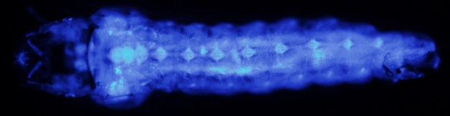
AsGTv3-041 | ASTE000537 | KB664510:112264-112267 | 3R 29 B(2) | KS331937 | fat body
AsGTv3-042 | ASTE011209 | KB664576:160341-160344 | 3R 29 B(2) | KS331938 | muscle | 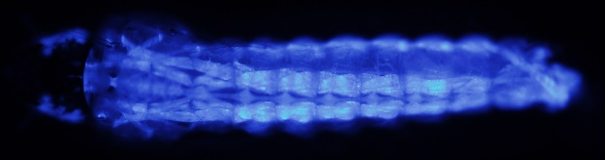
AsGTv3-043 | ASTE010607 | KB664460:324772-324775 | 3R 29 B(2) | KS331939 | muscle, neural, imaginal disc, fat body | 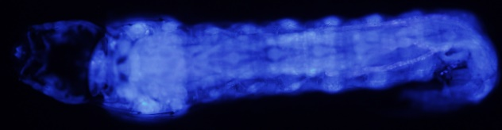
AsGTv3-044 | ASTE014976 | KB664621:1020724-1020727 | 3L 40 A(1) | KS331940 | muscle
AsGTv3-045 | ASTE007384 | KB664499:1131957-1131960 | 3L 40 A(1) | KS331941 | muscle | 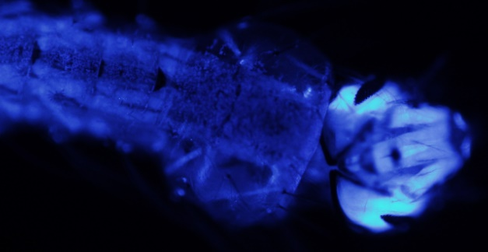
AsGTv3-046 | ASTE014976 | KB664621:1020724-1020727 | 2L 20 B(1) | KS331942 | muscle | 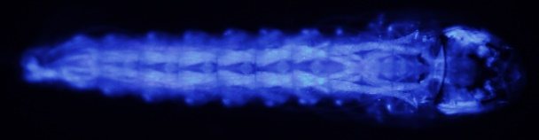
AsGTv3-047 | ASTE009011 | KB665132:108957-108960 | 2L 21 B(4) | KS331943 | salivary glands
AsGTv3-049 | ASTE001343 | KB665188:759697-759700 | 2L 21 B(4) | KS331945 | imaginal disc, neural
AsGTv3-050 | ASTE015161 | KB664456:136800-136803 | 2L 21 B(4) | KS331946 | fat body | 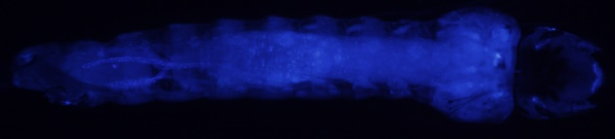
AsGTv3-051 | ASTE015161 | KB664456:136800-136803 | 3R 35 A(2) | KS331947 | fat body, neural | 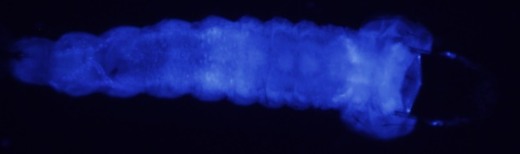
AsGTv3-052 | ASTE006314 | KB664288:636950-636953 | n/a | KS331948 | fat body, muscle | 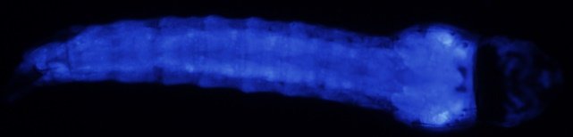
AsGTv3-053 | ASTE006224 | KB664455:946204-946207 | 2R 14 A(2) | KS331949 | fat body, neural
AsGTv3-054 | ASTE001365 | KB664622:83068-83071 | n/a | KS331950 | salivary glands, fat body | 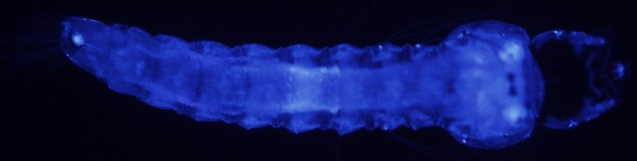
AsGTv3-056 | ASTE010484 | KB664844:881517-881520 | n/a | KS331952 | fat body, muscle | 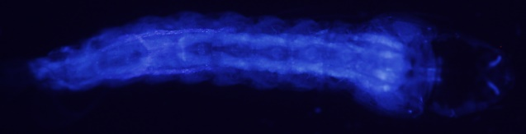
AsGTv3-058 | ASTE003422 | KB664527:4140-4143 | n/a | KS331954 | salivary glands | 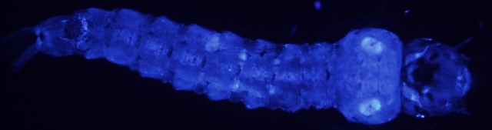
AsGTv3-059 | ASTE015161 | KB664456:136800-136803 | 2R 17 B(1) | KS331955 | fat body, compound eye
AsGTv3-061 | ASTE010484 | KB664844:881517-881520 | 2R 17 B(1) | KS331957 | muscle
AsGTv3-062 | ASTE005694 | KB664452:157283-157286 | n/a | KS331958 | fat body, muscle
AsGTv3-063 | ASTE002408 | KB665054:464174-464177 | 3R 35 B(2) | KS331959 | imaginal disc, neural, fat body
AsGTv3-064 | ASTE001343 | KB665188:763707-763710 | 3R 35 B(2) | KS331960 | imaginal disc, neural
AsGTv3-067 | ASTE005826 | KB664289:230172-230175 | n/a | KS331963 | salivary glands, anal papillae, fat body
AsGTv3-068 | ASTE010054 | KB664888:592198-592201 | n/a | KS331964 | fat body, imaginal disc
AsGTv3-069 | ASTE002419 | KB665054:801270-801273 | n/a | KS331965 | imaginal disc | 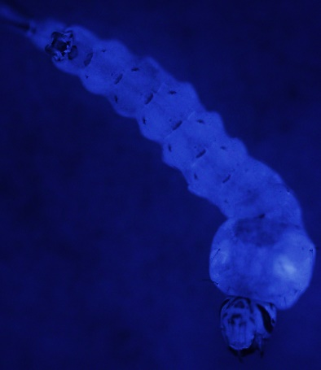
AsGTv3-070 | ASTE004973 | KB665354:444022-444025 | n/a | KS331966 | imaginal disc | 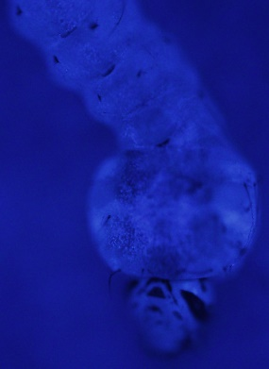
AsGTv3-071 | ASTE005820 | KB664289:193777-193780 | n/a | KS331967 | fat body, muscle
AsGTv3-072 | ASTE002023 | KB664494:78425-78428 | 2R 13 B(4) | KS331968 | neural, fat body, imaginal disc
AsGTv3-073 | ASTE008914 | KB664428:213902-213905 | 2L 22 B(1) | KS331969 | neurohumeral organs, neural, fat body
AsGTv3-074 | ASTE002310 | KB664977:84238-84241 | 2L 22 B(1) | KS331970 | fat body
AsGTv3-076 | ASTE009829 | KB664999:251634-251637 | 3L 45 C(1) | KS331972 | fat body, neurohumeral organs
AsGTv3-077 | ASTE006088 | KB664442:113439-113442 | 3L 45 C(1) | KS331973 | fat body
AsGTv3-078 | ASTE011601 | KB664677:375202-375205 | 2R 13 B(3) | KS331974 | fat body, midgut, Malpighian tubules, gastric cecae | 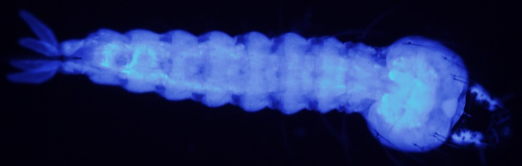
AsGTv3-079 | ASTE009536 | KB664400:666870-666873 | n/a | KS331975 | muscles | 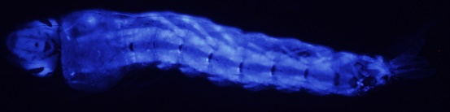
AsGTv3-080 | ASTE010054 | KB664888:592488-592491 | 2R 9 C(2) | KS331976 | fat body, imaginal disc
AsGTv3-081 | ASTE008097 | KB665088:632676-632679 | 3R 31 AB | KS331977 | neural
AsGTv3-082 | ASTE000883 | KB664899:550019-550022 | X 5 C | KS331978 | fat body, imaginal disc, neural | 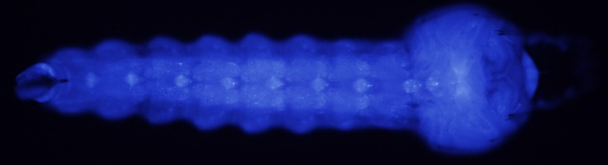
AsGTv3-084 | ASTE001018 | KB664721:838667-838670 | 3R 31 C(2) | KS331980 | imaginal disc, neural, fat body, anal papillae
AsGTv3-085 | ASTE008443 | KB664547:235269-235272 | 3R 30 A(3) | KS331981 | neural, imaginal disc, fat body, muscle
AsGTv3-087 | ASTE009536 | KB664400:666870-666873 | 3R 30 A(3) | KS331983 | muscles | 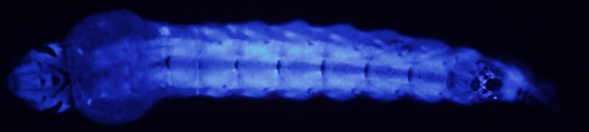
AsGTv3-088 | ASTE007233 | KB664571:135634-135637 | n/a | KS331984 | muscle, imaginal disc | 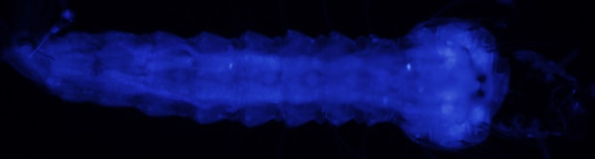
AsGTv3-089 | ASTE009536 | KB664400:674134-674137 | n/a | KS331985 | muscle | 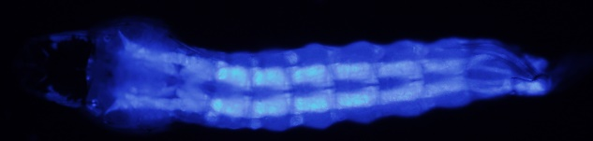
AsGTv3-090 | ASTE006277 | KB664587:104580-104583 | n/a | KS331986 | fat body, imaginal disc, muscle | 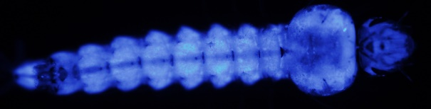
AsGTv3-091 | ASTE009536 | KB664400:666870-666873 | 2L 22 B(1) | KS331987 | muscles | 