A.
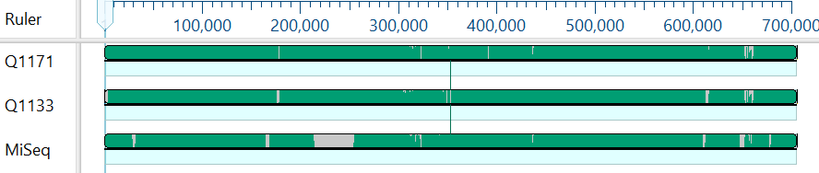

B.
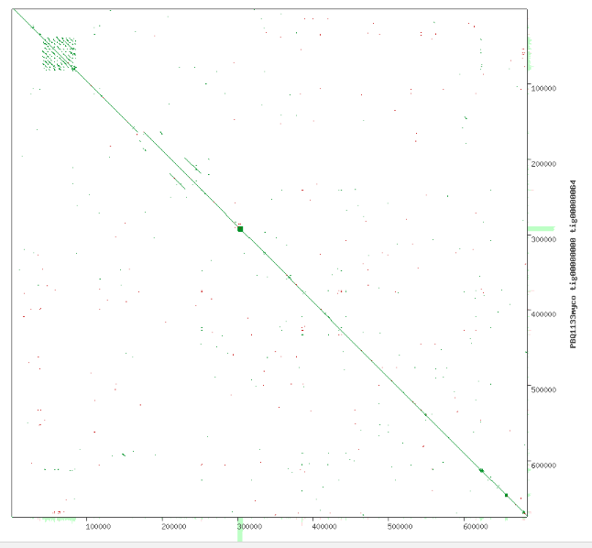

Fig S1 A. Mauve alignment of three PacBio assemblies of M. vittatus. Q1171 shows a 3601 bp extension at the 5’ end, whereas Q1133 shows a 650 bp overlap at the 3’ end.
B. Dot plot of PB1133 (X axis) and PB1171 (Y axis) indicates no overlap of extensions on the two assemblies.

